DEPARTMENT OF STATISTICS
ST. XAVIERS COLLEGE(AUTONOMOUS), KOLKATA



ASTROLOGICAL BELIEF PREDICTION
BASED ON PRIMART DATA COLLECTED

NAME: DANIEL DIBYAJYOTI MONDAL
ROLL NO: 415
REGISTRATION NUMBER: A01-1112-0700-22
SUPERVISOR: Dr. SANCHAREE BASAK
SESSION: 2022-2025

DECLARATION
I affirm that I have identified all my sources and that no part of my dissertation paper uses unacknowledged materials.

_____________________________________
DANIEL DIBYAJYOTI MONDAL
Department of Statistics
Roll no: 415
Reg. no: A01-1112-0700-22
St. Xaviers College (Autonomous), Kolkata

ACKNOWLEDGEMENT

I would like to express my special gratitude to Father Principal Rev. Dr. Dominic Savio SJ. and all authorities of St. Xavier’s College (Autonomous), Kolkata for maintaining such an enriching course on Statistics, which I proudly study under. I thank the Department of Statistics for giving me this amazing opportunity to work on this dissertation project.
I am deeply grateful to my dissertation supervisor Dr. Sancharee Basak for her constant guidance throughout my endeavour to produce this dissertation. Without her interventions major parts of my project would not have been fruitful. I express my sincere gratitude for being so gracious with her time and effort.
Additionally, I am thankful to all my professors in the department for equipping me with the statistical knowledge that enabled me to undertake this study. I also thank my family and friends for their continuous encouragement and support.

- Introduction
Since time immemorial, the idea of astrology and zodiac signs has been deeply rooted in various cultures worldwide that sought to understand human existence through celestial movements. The Babylonians, influenced by the Greeks, were the first to refine astrology by integrating philosophical and mathematical concepts. Ptolemy (2nd Century C.E.) compiled astrological concepts in his key work, Tetrabiblos, which constitutes the cornerstone of Western astrology. Around the same time, Vedic Astrology (Jyotish vidya) flourished in India.
Despite the scepticism astrology remains omnipresent in the modern era, especially in psychology, and entertainment. From casual horoscope readers to devoted believers whose life decisions are influenced by their astrologer, zodiac signs have always fascinated humanity. One might blame the position of Mars for their problems or just skip the pages on zodiac predictions from magazines, one cannot deny the impact of astrology in modern culture. The lack of scientific backing did not stop astrology from gaining popularity and continues to influence people, consciously or unconsciously. A person might hesitate to wear a red shirt on hearing it's unlucky for that particular day, while the other might just wear it, just to prove it wrong. Either way, the influence remains.
This project attempts to decipher the factors that may lead young individuals to believe in astrology. The study encompasses demographic, social and psychological factors along with one’s prior exposure to astrology in predicting the individual’s belief in astrology.

2. Literature Review
The study of astrological belief intersects with psychology, sociology, and cognitive science. Prior research has linked astrological belief to a range of cognitive biases, personality traits, and sociocultural influences. This section reviews key findings in these areas to build a foundation for our predictive analysis.

2.1. Psychological and Cognitive Factors
The Barnum effect (Forer, 1949) suggests that individuals tend to accept vague and generalized statements as highly accurate and personal, which in case of astrology leads to increase one’s belief. Additionally, confirmation bias (Nickerson, 1998) leads believers to specifically recall those instances where horoscopes appeared accurate while ignoring contradictions otherwise.
Astrological belief has also been attributed to locus of control (Rotter, 1966), where individuals those who attribute events in life to external forces—are more likely to believe in astrology. Furthermore, individuals experiencing higher levels of stress, risk and uncertainty have been found to fall back to astrology, as a coping mechanism, finding peace and solace in events determined by external forces (Lillqvist & Lindeman, 1998).

2.2. Personality and Individual Differences
Personality traits astrological belief to a certain extent. Studies using the Big Five personality model (McCrae & Costa, 1987) suggest that individuals high in openness to experience are more likely to engage with astrology due to their curiosity about novel and mystical ideas (Lindeman & Aarnio, 2007). Conversely, higher levels of neuroticism have been associated with greater reliance on astrology, possibly due to anxiety-driven tendencies to seek structure and reassurance in uncertain situations.
Impulsivity and belief in the supernatural also correlate with astrological belief. Research suggests that those who score high in impulsivity and sensation-seeking tendencies may be more likely to engage with astrology due to their attraction to novel and unverified ideas (Wiseman & Watt, 2004).

2.3. Socio-cultural Influences
Cultural background and religious affiliation play significant roles in shaping astrological belief. Studies have found that societies with strong religious traditions may either reinforce or discourage astrological belief, depending on theological perspectives (Truzzi, 1972). For instance, some religious communities reject astrology as incompatible with their doctrines, while others incorporate astrological interpretations into spiritual practices.
Social learning also contributes to astrological belief. People exposed to astrology from a young age, either through family traditions or popular media, may develop a stronger attachment to it. The rise of digital astrology, particularly through social media platforms, has further amplified belief in astrology among younger generations, reinforcing astrological concepts through daily horoscopes and algorithm-driven content (Pew Research Centre, 2018).

  - Summary
The literature suggests that astrological belief is influenced by a combination of psychological predispositions, personality traits, and sociocultural factors. Cognitive biases, external locus of control, and high stress levels contribute to belief persistence, while openness to experience and impulsivity enhance engagement with astrology. In the modern era, social media plays an increasing role in shaping and reinforcing astrological belief. This study builds on these findings by applying predictive modeling techniques to determine which factors most significantly impact astrological belief.
Prior research indicates that astrological belief correlates with openness to experience, cognitive biases, and cultural background. Some studies link belief to higher stress levels and a need for control. Others suggest that belief in astrology aligns with a tendency toward magical thinking and an external locus of control. Furthermore, research on superstition suggests that people experiencing uncertainty are more likely to seek comfort in astrological interpretations. This paper builds on existing literature by incorporating a broader range of factors, including mental health, lifestyle, and personality traits, to develop a comprehensive model of astrological belief formation.

- Dataset Description
The dataset consists of data on 100 students from the age group 17 to 24 (Undergraduate and Postgraduate students) studying at St. Xavier’s College (Autonomous), Kolkata. Data consists of 26 columns including information on:
- Dependent Variable: Belief in Astrology (Ordinal with 3 levels).
(The dependant variable has lesser levels to facilitate prediction.)

- Independent Variables:

- Demographic factors:
- Gender: Records the gender of the individual (Nominal with 2 levels- Male and Female).
- Age: Records the age of the individual (Continuous with range 17-22)
- Education: Records the highest educational degree obtained by the individual. (Nominal with 2 levels- Higher School Graduate and BSc Graduate).
- Hometown: Records the city of residence of the individual (Nominal with 38 levels).

- Social and Cultural factors:
- Ethnicity: Records the Ethnic or cultural group the individual belongs to. (Nominal with 16 levels).
- Culture: A summarised variable for Ethnicity, based on whether the individual belongs to Bengali Community or not. (Nominal with 2 levels- Bengali and Non- Bengali)
- Religion: Records the religion of the individual (Nominal with 4 levels- Hinduism, Christianity, Islam and Atheism).

- Personality Traits:
- Optimism: Optimism level for an individual (Ordinal with 5 levels).
- Empathy: Empathy level for an individual (Ordinal with 5 levels).
- Patience: Patience level for an individual (Ordinal with 5 levels).
- Impulsivity: Impulsivity level for an individual (Ordinal with 5 levels).
- Organization: Organisation skill of an individual (Ordinal Scale with 5 levels).
- Nature: Nature of the Individual (Nominal with introvert, extrovert and ambivert).

- Lifestyle & Health Factors:
- Health: Records the general health condition (Ordinal Scale with 5 levels).
- Mental health: Records the mental health condition (Ordinal Scale with 5 levels).
- Stress level: Records the average stress level (Ordinal Scale with 5 levels).
- Medication: Records regular medication use (Nominal with 2 levels- yes/no).
- Diseased: Records the presence of any terminal/ chronic or lifestyle disease (Ordinal Scale with 5 levels).
- Lifestyle: Records how comfortable one’s daily life is (Ordinal Scale with 5 levels).

- Astrological Engagement:
- Zodiac: Stores the zodiac sign of the individual (Nominal with 12 levels).
- Checking. Forecasts: Records how often the individual checks newspapers or the internet for forecasts (Ordinal Scale with 5 levels).
- Visiting. Astrologers: Records how often does the individual visits an astrologer (Ordinal Scale with 5 levels).
- Reason: Stores the reason for visiting an astrologer. (Nominal with 4 levels).
- Acknowledgment: Records the degree to which one acknowledges astrology (Ordinal with 5 levels).

- Methodology

  - Primary data collection:
A google form was circulated in different forms of social media., with the target audience being the students. The form contained questions regarding traits that might affect one’s belief on astrology. The questionnaire was strictly directed to the students of St. Xavier’s College (Autonomous), Kolkata. The questionnaire was filled up 107 students. But after cleaning the data by removing wrong inputs and missing values, the data boiled down to 100 unique observations.
Since most of the variables under study are ordinal or nominal with very few levels, multiple-choice questions (MCQ) were a majority in the Questionnaire. Short answer type questions were kept for factors like Hometown and Ethnicity as there were many levels. The questions are listened below.

Questionnaire:

- Name:
- College:
- Department code and Year (E.g. STSA-UG3):

- How frequently do you acknowledge the relevance of astrology?
- Never
- Sometimes
- Occasionally
- Often
- Always

- How often do you check newspapers or the internet to look into the astrological forecasts?
  - Never
  - Sometimes
  - Occasionally
  - Often
  - Always

- How often do you visit an astrologer?
  - Never
  - Sometimes
  - Occasionally
  - Often
  - Always
- What was the reason behind you visiting an astrologer?
- Curiosity
- Influenced by others
- Belief
- Never visited
- Others………

- How strong is your belief in astrology?
- Weakest
- Weak
- Moderate
- Strong
- Strongest

- What would be your astrological sign, based on your birthdate?
- ♈ Aries: (March 21–April 19)
- ♉ Taurus: (April 20–May 20)
- ♊ Gemini: (May 21–June 21)
- ♋ Cancer: (June 22–July 22)
- ♌ Leo: (July 23–August 22)
- ♍ Virgo: (August 23–September 22)
- ♎ Libra: (September 23–October 23)
- ♏ Scorpius: (October 24–November 21)
- ♐ Sagittarius: (November 22–December 21)
- ♑ Capricornus: (December 22–January 19)
- ♒ Aquarius: (January 20–February 18)
- ♓ Pisces: (February 19–March 20)

- Based on the following attributes, please give yourself an objective rating (1 to 5).
  - Optimism:
  - Empathy:
  - Patience:
  - Impulsivity:
  - Organisation skills:

- Please enter your age:

- Please choose your gender:
- Male
- Female
- Others
- How would you describe your health condition?
- Very Unhealthy
- Unhealthy
- Moderately Healthy
- Healthy
- Very Healthy

- Do you suffer from any disease? (periodic/ terminal/ lifestyle)
- Yes
- No

- Are you currently undergoing any form of medication?
- Yes
- No

- How would you describe your mental health?
- Very Unhealthy
- Unhealthy
- Moderately Healthy
- Healthy
- Very Healthy

- How much stress do you take in your day-to-day life?
- Negligible
- Low
- Moderate
- High
- Extreme

- what would you consider your nature to be?
- Ambivert
- Introvert
- Extrovert

- How favourable and comfortable would you consider your daily life to be (taking into account all the different aspects of life)?
- Very Uncomfortable
- Uncomfortable
- Moderately Comfortable
- Comfortable
- Very Comfortable

- Please rate your problem-solving abilities.
- Weakest
- Weak
- Moderate
- Strong
- Strongest

- What is your highest level of education achieved?
- What would you consider your cultural background or ethnicity to be?
- What religion do you follow?

With this we conclude our primary data collection.

4.2 Exploratory Data Analysis (EDA):
The variable belief has three levels- 1 (Weakest), 2 (weak), 3 (Moderate) and 4 (Strong). We observe that the highest level of belief is absent in the data set, implying that students don’t have a very strong dependence on astrology.
We observe the proportion of the Belief levels using a pie chart:

Further we construct graphs for some the dependent variable, Belief with respect to different independent variables. The interpretation of the graphs between Belief and the independent variables is given below.
- Acknowledgement of the Relevance of Astrology:

Acknowledgement has 5 levels- 1 (Weakest), 2 (Weak), 3 (Moderate), 4 (Strong) and 5 (Strongest). This variable measures the degree to which a person agrees to the influence on astrology in daily life. We should not confuse it with belief as Belief has faith involved. While acknowledgement is more on the empirical side, relating to observations in day-to-day life.
We obtain the graphs as:

We observe the following, from the above charts:
- The strongest level (=5) of Acknowledgement is absent.
- An increase in proportion is seen for the higher levels of Acknowledgement (3 and 4), while the proportion of the lower levels (1 and 2) decreases. At a strong level of Belief (=4) we only see the strong levels of Acknowledgement, indicating a strong level of association between Belief and Acknowledgement.
- The majority of individuals at the lowest level of Belief, also have no acknowledgement for it, though we see exceptions (roughly around 35%) where the individuals with the weakest level of Belief (=1) were seen to have a stronger level of acknowledgement. Hence, we can derive a conclusion that a person might not believe in astrology, but still be curious and indulge in it.

- Age
The dataset contains the data on individual from the age group of 17 to 24. The data comprises of students from the post graduate and under graduate programmes of;
St. Xavier’s college (Autonomous), Kolkata. The data has been discretized. The Age distribution with respect to the belief levels is given as:

The median age for first, third and fourth level belief seems to be 20, and the median for the second level is 19. We see that no outliers are present. We see that both students with a higher age (22, 23 and 24) and the lowest age (17) have a lower level of belief indicated that the oldest and the youngest are sceptical about astrology here.

- Nature of the Individual:

A person’s nature can have important role in building up ideologies, the interaction with other people playing a major role in it. The variable nature has three levels: Introvert, Extrovert and Ambivert.

We observe from the above charts that:
- Exactly 50% of the individuals are Ambiverts, which was the expected outcome from a survey on students. The proportion of introverted students is double that of the proportion of extroverts, the pandemic might be a leading factor.
- The proportion of Ambiverts is seen to increase on an average, as the level of Belief is increased, while the proportion of introverts decreases. The proportion of extroverts remains somewhat equal, with an increase in the higher level of Belief.

- Religion:
There are four levels of religion that are: Atheist, Christianity, Hinduism and Islam.

We see a clear majority in the number of individuals who follow Hinduism. Hence using a stacked bar diagram to visualise the effect of Religion would be faulty.

- General Health of the individual:

This variable records the general health of the individual. The variable Health has five levels: 1 (Very Unhealthy), 2 (Unhealthy), 3 (Moderate), 4 (Healthy) and 5 (Very Healthy).

we obtain a pie chart for the different Levels of Health as:

From the two charts we observe that we observe that:
- Most individuals are moderately healthy or higher. Since our population consists of only students, this result was expected.
- The proportions of the strong Health increases with increase in the level of Belief.
- We can infer that mostly in students, the individuals that are healthier have a stronger belief for astrology.
- Though for the highest level of health

- General Health of the individual:

From the graphs we see that:
- Both the genders have an approximately similar proportion
- With the increase in the belief level, the proportion of males slightly increases while the proportion of females decreases.
- The spread remains close to 50% only, except at the 4th level where 60% to 40%.
- Presence of any Form of Disease- (Terminal/ Lifestyle/ Chronic)

The variable diseased records the presence of any form of disease. The variable is a binary variable with levels yes or no.

From the two charts we observe that:
- The proportion of non-diseased individuals is much higher compared to the diseased individuals.
- The proportion of people who voted under yes increases significantly, as the level of astrological belief reached its maximum level.
- We can conclude that the presence of disease leads to an increase in the astrological belief.

- Ongoing Medication:

These variable records whether a person is undergoing any form of regular medication, for some sort of condition or ailment. The variable is a binary variable with levels yes or no, denoting whether there is a regular consumption or not.

From the graphs we see that:
- The majority of individuals do not undergo any form of medication.
- A very similar picture between the graph of medication and diseased. Intuitively they will have a very strong association, might suggest multicollinearity.
- The proportion of individuals under medication are seem to increase as the level of Belief increases.

- Mental Health

This variable records the state of an individual’s mental health. Mental Health has 5 levels: 1 (Very Unhealthy), 2 (Unhealthy), 3 (Moderate), 4 (Healthy) and 5 (Very Healthy).
We obtain the pie chart of the factor Mental Health as:

From the graphs we see that:
- Most students have a healthy state of mind
- Individuals with a healthier mind are more prone to believe in astrology.

- Lifestyle
The variable lifestyle records the level of comfort an individual has in their life. There are 5 levels – 1 (Very Uncomfortable), 2 (Uncomfortable), 3 (Moderate), 4 (Comfortable) and 5 (Very Comfortable)

From the graph we see that:
- Individuals with a more comfortable lifestyle indulge in astrology.
- This variable could not show its full effect as the observations on the lower levels are quite low or negligible.
  - Regression Analysis
To successfully predict the level of belief for the individuals we use the method of ordinal regression.
Ordinal regression, also known as ordinal logistic regression or the cumulative logit model, is a statistical modelling technique used to predict an ordinal dependent variable based on one or more independent variables. An ordinal variable is one that has a clear, ranked order, but the intervals between the ranks are not necessarily uniform or known. In the context of this study, the dependent variable — degree of belief in astrology — is ordinal in nature, typically ranked as low, moderate, or high, and is influenced by a set of predictors including personality traits, mental health indicators, demographic factors, and cultural background.

4.3.1 Nature of Ordinal Data
The unique characteristic of ordinal data is that it combines the properties of both categorical and quantitative data. While the categories are discrete and finite, they also carry a meaningful order. For example here the depend variable has 5 levels (1 = Weakest, 2 = Weak, 3 = Moderate and 4 = Strong belief in astrology), has a natural ordering.

4.3.2 The Proportional Odds Model
The most widely used form of ordinal regression is the proportional odds model, proposed by McCullagh (1980).
The general mathematical formulation of the model is:
$$\log\left(\frac{P\left(Y≤j\right)}{P\left(Y>j\right)}\right)=α_{j}-(β_{1}X_{1}+ β_{2}X_{2}+…+ β_{k}X_{k})$$
Where:
- Y is the ordinal outcome variable (e.g., Belief score)
- $j∈ \{1 ,…, c-1\}$ represents the cumulative threshold points (here c=4).
- $α_{j}$​ are the threshold (intercept) parameters to be estimated for each category.
- $β_{k}$ are the regression coefficients associated with predictors $X_{k}$​.
This formulation models the log-odds of being at or below a particular level of the outcome as a linear function of the predictors. The coefficients ​$β_{k}$ are assumed to be constant across all thresholds — a crucial requirement of the proportional odds model.

We compute the marginal probabilities as follows:
We can rearrange this expression to obtain cumulative probabilities:
$$P\left(Y≤j\right)=\frac{1}{1+exp\left(α_{j}-\sum_{i}{β_{i}X_{i}}\right)}=\frac{1}{logit\left(α_{j}-\sum_{k}{\sum_{l}{β_{kl}X_{kl}}}\right)}$$
- Where: $α_{j}$is the j^{th} intercept, j = 1(1)3
- $β_{jk}$ are the l^{th} level of the k^{th} factor depending on the model.

Now for the different levels of Belief the expression for cumulative probability is given by:
$$P\left(Y=1\right)=P\left(Y≤1\right)$$
$$P\left(Y=2\right)=P\left(Y≤2\right)-P\left(Y≤1\right)$$
$$P\left(Y=3\right)=P\left(Y≤3\right)-P\left(Y≤2\right)$$
$$P\left(Y=4\right)=1-P(Y≤3)$$

4.3.4 Assumptions of the Model
Ordinal regression relies on the following core assumptions:
- Ordinal nature of the response variable: The dependent variable must represent ordered categories.
- Independent observations: Each case must be independent of the others.
- Adequate sample size: There must be a sufficient number of observations in each category to ensure model stability and validity.

4.3.5 Relevance to the Current Study
Given the ordinal nature of the Belief variable and the presence of diverse predictor variables such as:
- Personality traits (e.g. Optimism, Empathy, Patience, Nature, etc.)
- Demographic factors (Age, Gender, Education)
- Socio-cultural factors (e.g. Hometown, Ethnicity, Religion)
- Health and Lifestyle (e.g. Health, Mental health, Medication status etc)
- Astrological engagement (e.g., Checking forecasts, Visiting astrologers),

Ordinal regression provides a robust analytical framework. It enables the exploration of how each of these factors statistically influences the intensity of astrological belief, beyond merely predicting belief presence or absence. This model preserves the inherent order in the response variable while handling the complexity of multiple independent variables.

4.3.6 Regression Findings
We first regress our dependant variable Belief, on the different categories of independent variables (as mentioned in the data description). Using the proportional odds model and estimate the regression parameters. We report the measures of:
Model Accuracy $= \frac{Number of observations correctly predicted}{Total Number of Observation}$.

Social and Cultural factors:
The factors Religion and Ethnicity are considered to Social and Cultural factors. The estimates of the model parameters are given by:

INTERCEPTS | VALUE | STANDARD ERROR
1|2 | 21.4408 | 0.6872
2|3 | 23.7613 | 0.6073
3|4 | 25.8369 | 0.8605

SOURCES OF VARIATION | SLOPE  COEFFICIENTS | STANDARD  ERROR
ETHNICITY:
Bihari | -1.502 | 1.972
Chinese | -0.6216 | 2.024
Delhite | 32.97 | 0.7494
Kashmiri | -1.5E-05 | 4.633E-13
Kshtriya | -1.502 | 1.972
Lepcha | -0.7165 | 1.963
Lucknowavi | -1.502 | 1.972
Maithili | -2.45 | 1.632
Manipuri | 1.577 | 1.999
Marwari | -0.393 | 1.481
Oraon | -20.57 | 5.497E-08
Oriya | -22.57 | 2.107E-08
Punjabi | -1.502 | 1.972
Rajput | 20.45 | 5.071E-08
Tamilian | -22.57 | 2.107E-08
RELIGION:
Christianity | 23.22 | 0.8616
Hinduism | 24.1 | 0.8053
Islam | -8.167 | 0.7494

Here the levels, Bengali for Ethnicity and Atheist for Religion are considered to be the base levels.
Here if we take an example of the factor Religion. We consider the levels Christianity. Let the estimates of the slope coefficients be $β_{C}=23.22$. Considering all other factors to be constant, the odds of belonging to a higher belief level, for the individual long who has opted for Christianity is given by: $e^{-β}$
Interpretation: From the model, the odds of a Christian individual belonging to a higher belief level is: $e^{-β_{C}}= e^{-23.22}= 8.235351 × {10}^{-11}$
The confusion matrix between the actual and predicted Belief values with respect to the Social and Cultural factors is given by:

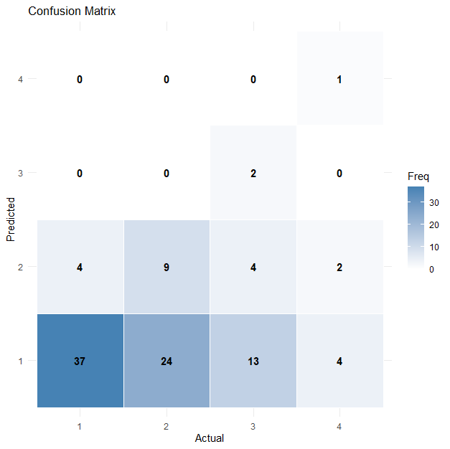
The Model Accuracy = 0.49 or 49%

The fit seems to be moderate

Demographic factors:
The factors Age, Gender and Education constitute the demographic factors. The estimates of the model parameters are given as:
INTERCEPTS | VALUE | STANDARD ERROR
1|2 | -33.7185 | 3.581
2|3 | -31.7049 | 3.5384
3|4 | -29.4951 | 3.5538

SOURCES OF VARIATION | SLOPE  COEFFICENT | STANDARD  ERROR
Age | -0.2062 | 0.1844
GENDER: Male | -0.5704 | 0.5021
EDUCATION:
U.G. GRADUATE | -1.3562 | 0.9711
HOMETOWN:
Asansol | -29.3952 | 1.515
Bally | -28.9326 | 1.318
Bandel | -27.2651 | 1.593
Baramulla | -41.616 | 0.000008068
Bardhamann | -27.2172 | 1.684
Baruipur | -29.1443 | 1.149
Batanagar | -39.7584 | 0.00001711
Chandannagar | -29.1289 | 1.355
Chennai | -40.4292 | 0.00001646
Coochbehar | -24.9469 | 1.665
Darbhanga | -27.0589 | 1.61
Deoghar | -24.9469 | 1.665
Dumka | -40.9058 | 0.000009407
Gumla | -57.4143 | 1.513E-11
Haflong | -24.7412 | 1.704
Hooghly | -40.9058 | 0.000009407
Howrah | -27.0562 | 1.249
Kakdwip | -40.6603 | 0.00001652
Kalyani | -27.4357 | 1.972
Katwa | -40.1221 | 0.00002055
Kharagpur | -27.2299 | 2.001
Khardah | -27.6295 | 1.606
Kolkata | -27.7795 | 0.4883
Konnagar | -25.4454 | 1.364
Kurseong | -41.616 | 0.000008068
Lucknow | -27.0589 | 1.61
Mednipur | -26.4369 | 1.244
Naihati | -27.4713 | 1.597
New Barrackpore | -40.1221 | 0.00002055
Odisha | -27.8357 | 1.598
Raghunathganj | -56.9087 | 1.853E-11
Rajasthan | -40.4292 | 0.00001646
Rajpur | -42.6044 | 0.000003877
Raniganj | -3.8143 | 9.515E-09
Sainthia | -40.128 | 0.00006141
Siliguri | -25.518 | 1.653
Tinsukia | -27.8357 | 1.598

Here the levels, Highschool Graduate for Education, Female for Gender and Arambagh for Hometown are considered to be the base levels.
Here if we take an example of the factor Gender. The estimate of the slope coefficient of the level: Male is given by $β= -0.5704$
Interpretation: From the model, the odds of a male individual belonging to a higher belief level is: $e^{-β}= e^{0.5704}= 1.768974$

The confusion matrix of the predicted and actual value of Belief with respect to the demographic factors is given below:
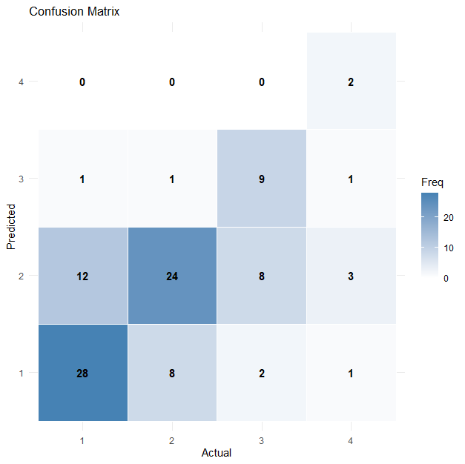
The model accuracy = 0.63 or 63%.

The fit seems to be a decently good fit.
Lifestyle and Health factors:
The factors Health, Mental Health, Stress Level, Lifestyle, Medication and Diseased are considered to be Lifestyle and Health factors. We estimate the model parameters as:

INTERCEPT | VALUE | STANDARD ERROR
1|2 | 0.1131 | 0.6414
2|3 | 1.7882 | 0.6741
3|4 | 3.5183 | 0.76

SOURCE OF VARIATION | SLOPE  COEFFICIENTS | STANDARD  ERROR
HEALTH:
Moderately Healthy | 0.3711 | 1.0387
Healthy | 0.48983 | 0.7314
Very Healthy | -0.58398 | 0.4369
MENTAL HEALTH:
Unhealthy | -1.53482 | 1.0056
Moderately Healthy | -0.6877 | 0.8562
Healthy | -1.85829 | 0.7104
Very Healthy | 0.53491 | 0.46
STRESS LEVEL:
High | 0.91165 | 1.2736
Moderate | -1.03973 | 1.0818
Low | -0.24681 | 0.7608
Negligible | -0.04511 | 0.4825
LIFESTYLE:
Moderate | 1.73426 | 0.9255
Comfortable | 1.34619 | 0.7246
Very Comfortable | 0.7839 | 0.4412
Medication: yes | 0.58487 | 0.6401
Diseased: yes | 0.6711 | 0.6429

Here the levels, Unhealthy (=2) for Health, Very Unhealthy (1) for Mental Health, Very High (1) for Stress Level, Uncomfortable for Lifestyle, No for Diseased and No for Medication, are considered to be the base levels.
Here if we take an example of the factor Medication. The estimate of the slope coefficient of the level: Male is given by $β= 0.58487$
Interpretation: From the model, the odds of an individual undergoing medication to have a higher belief level is: $e^{-β}= e^{-0.58487}= 0.57717$

The confusion matrix of the predicted and actual value of Belief with respect to the Lifestyle and Health factors is given by:
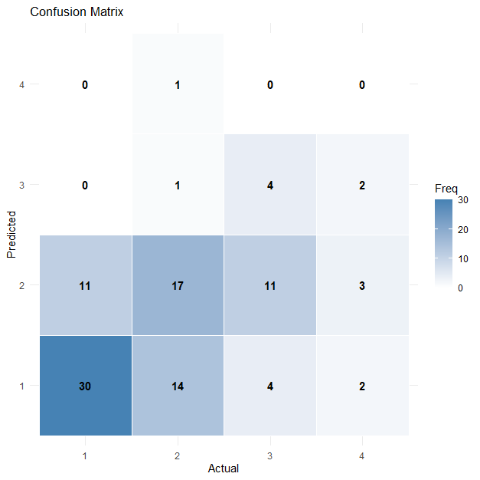
The Model Accuracy = 0.51 or 51%

We consider this to be a moderate fit.

Personality Traits:
Traits like Optimism, Empathy, Organizing Skills, Impulsivity, Patience and Nature are the personality traits. We obtain the regression parameters as:

INTERCEPT | VALUE | STANDARD ERROR
1|2 | 0.0037 | 0.4711
2|3 | 1.761 | 0.5163
3|4 | 3.6427 | 0.6429

SOURCES OF VARIATION | SLOPE  COEFFICIENT | STANDARD  ERROR
OPTIMSIM
Weak | -0.717 | 1.1303
Moderate | -1.3804 | 0.7915
Strong | 0.4479 | 0.5764
Strongest | -0.5664 | 0.512
EMPATHY
Weak | 0.8824 | 1.0963
Moderate | 1.416 | 0.7206
Strong | -0.2197 | 0.4878
Strongest | 0.552 | 0.6745
ORGANISED
Weak | 0.6887 | 0.8868
Moderate | -0.9556 | 0.6982
Strong | -0.1118 | 0.5769
Strongest | -0.8806 | 0.4972
IMPULSIVITY
Weak | -0.291 | 0.7551
Moderate | 0.1966 | 0.614
Strong | -0.4996 | 0.5473
Strongest | 0.9507 | 0.5241
PATIENCE
Weak | -2.1152 | 1.032
Moderate | -0.8383 | 0.8216
Strong | 0.3289 | 0.6257
Strongest | -0.3449 | 0.5006
APTITUDE
Weak | 9.4835 | 0.5294
Moderate | -9.9979 | 0.5593
Strong | 5.1336 | 0.5505
Strongest | -1.6479 | 0.4758
NATURE:
Extrovert | 0.4294 | 0.6501
Introvert | -0.2869 | 0.5194

Here the levels, Weakest (=1) for Optimism, Weakest (=1) for Empathy, Weakest (=1) for Organized, Weakest (=1) for Impulsivity, Weakest (=1) for Patience, Weakest (=1) for Aptitude and Ambivert of Nature, are considered to be the base levels.
Here if we take an example of the factor Nature. The estimate of the slope coefficient of the level: Introvert is given by $β= -0.2869$
Interpretation: From the model, the odds of an introverted individual to belonging to a higher belief level is: $e^{-β}= e^{0.2869}= 1.3322$

The confusion matrix of the actual and predicted values of Belief.
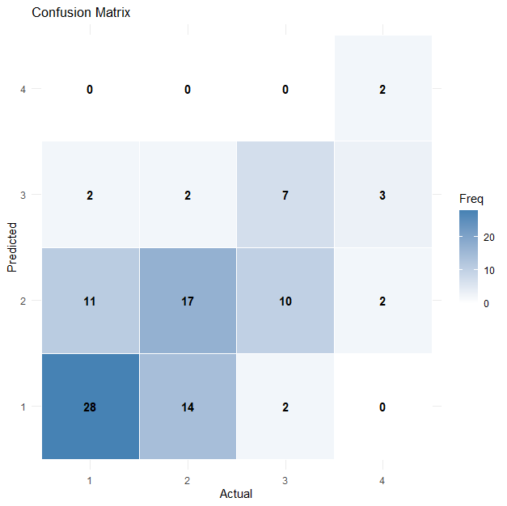
Model Accuracy = 0.54 or 54%
We consider this to be a moderate fit.
Astrological Engagement Factors:
The factors Checking Forecasts, Visiting Astrologer, Reason for Visiting, Acknowledgement, and Zodiac Signs are Astrological Engagement factors. The regression parameters are estimated by:
INTERCEPT | VALUE | STANDARD ERROR
1|2 | -17.7001 | 1.1762
2|3 | -15.0777 | 1.23
3|4 | -12.1432 | 1.2842

SOURCE OF VARIATION | SLOPE  VALUE | STANDARD  ERROR
CHECKING FORECASTS
Rarely | 11.04388 | 0.946
Occasionally | 10.44252 | 0.4458
Often | 8.013 | 0.9812
Very Often | 2.86791 | 0.9468
VISITING ASTROLOGER
Rarely | 11.4071 | 0.7734
Occasionally | 8.6403 | 0.8867
Often | 5.30882 | 0.9695
Very Often | 28.65947 | 0.6707
ACKNOWLEDGEMENT
Moderately | 20.5668 | 0.4955
Strong | 12.83699 | 0.5569
Very Strong | 4.6936 | 0.5224
REASON FOR VISITING
Curiosity | -2.24659 | 1.3919
Have not visited | -1.65759 | 1.4465
Influnced by Others | 0.73887 | 1.4421
ZODIAC SIGNS
Aries | 1.05567 | 1.1996
Cancer | 0.97008 | 1.2844
Capricornus | -0.01229 | 1.0966
Gemini | 1.76541 | 1.5352
Leo | -0.17304 | 1.3237
Libra | 2.14187 | 1.1175
Pisces | 2.33125 | 1.2725
Sagittarius | 1.09187 | 1.0244
Scorpius | 0.13568 | 1.1224
Taurus | 1.74046 | 1.2391
Virgo | 0.57679 | 1.2524
Here the levels, Never (=1) for Checking forecasts, Never (=1) for Visiting Astrologer, Never (=1) for Acknowledgement, Beliefs for Reason and Aquarius for Zodiac Sign are considered to be the base levels.
Here if we take an example of the factor Reason. The estimate of the slope coefficient of the level: Curiosity is given by $β= -2.24659$
Interpretation: From the model, the odds of an individual whose reason for following astrology is curiosity, to have a higher belief level is: $e^{-β}= e^{0.2869}= 9.45543$
The confusion matrix is given by:

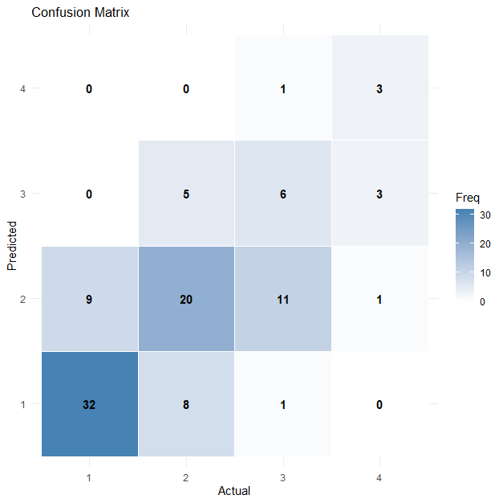
The model accuracy = 0.61 or 61%

We consider this to be a considerably good fit.

We compare the accuracies of the different broad groups of factors in the dataset by:
GROUP | VARIABLES PRESENT | ACCURACY
Social and Cultural Factors | Ethnicity and Religion | 49%
Demographic  Factors | Age, Gender and Hometown | 63%
Personality  Traits | Nature, Optimism, Empathy, Patience, Impulsivity, Organised, Aptitude | 54%
Lifestyle and Health Factors | Health, Diseased, Medication, Mental health and Lifestyle | 51%
Astrological Engagement Factors | Acknowledgement, Checking forecasts, Visiting Astrologer, Reason and Zodiac. | 61%

From the table interpret:
- We observe that the demographic factors combined has a strong effect in predicting the level of belief, although individually the factors don’t have much significance.
- Astrological engagement is seen to have a good effect on the prediction was an expected result as there would be a strong relationship with Belief.
- Social and Cultural factors having moderate relationship while predicting the levels of Belief shows that astrological belief is not just prevalent in a particular religion or ethnicity, it varies from person to person, belonging to different castes and creeds.
- Personality traits, Lifestyle and Health factors have a moderate effect as the sample is drawn from a population of students hence the effect of these factors is not fully realised.

Based on the accuracy levels we would want to consider factors from all the broad groups as all of them are moderately accurate in predicting the Belief levels. The problem of over- parametrization occurs in this scenario as the number of observations is quite small. To facilitate the fitting of the model we select ten variables with the highest association with the dependent variable, Belief. We use the Goodman-Kruskal gamma measure for measuring the association.
Goodman Kruskal’s gamma = $\frac{C-D}{C+D}$ ,
where C = number of concordant pairs
D = number of discordant pairs.

Final Model:
We note down the association between the response Belief and the various factors in the table given below:
Variable | Goodman Kruskal’s Gamma Measure
ASTROLOGICAL ENGAGEMENT
Acknowledgement | 0.670
Checking forecasts | 0.720
Visiting Astrologer | 0.520
Reason for Visiting | 0.660
Zodiac | 0.220
PERSONALITY TRAITS
Optimism | 0.013
Empathy | 0.120
Patience | -0.120
Impulsivity | 0.160
Organisation | 0.080
Nature | -0.170
Aptitude | -0.178
LIFESTYLE AND HEALTH FACTOR
Health | 0.150
Diseased | 0.250
Medication | 0.290
Mental.Health | -0.001
Stress | -0.004
Lifestyle | 0.180
DEMOGRAPHIC FACTORS
Age | 0.030
Gender | 0.098
Hometown | 0.038
Education Level | -0.260
SOCIAL AND CULTURAL FACTORS
Ethnicity | 0.150
Religion | 0.280
Culture | 0.180

We consider the 10 variables with the highest level of association between the dependent variable Belief and the respective variable. The variables included in the model are Acknowledgement, Checking Forecasts, Visiting Astrologer, Reason, Zodiac, Diseased, Medication, Education Level, Culture and Religion. (As defined in the data description)
The estimates of the model parameters are given by:
INTERCEPT | VALUE | STANDARD ERROR
1|2 | 6.383 | 1.0469
2|3 | 9.1347 | 1.075
3|4 | 11.7092 | 1.1073

SOURCES OF VARIATION | SLOPE  COEFFICIENTS | STANDARD  ERROR
EDUCATION:
Highschool Graduate | 0.4016 | 0.6643
ACKNOWLEDGEMENT:
Weak | 4.1758 | 1.0393
Moderate | -0.4478 | 0.6103
Strong | 0.6944 | 0.4768
CHECKING FORECASTS:
Rarely | 9.0505 | 0.8153
Sometimes | 6.5803 | 0.9563
Often | 3.5382 | 0.9834
VISITING ASTROLOGER:
Rarely | 13.0054 | 0.9504
Sometimes | 11.8021 | 0.4621
Often | 8.6956 | 1.0674
Very Often | 2.5369 | 0.9872
DISEASED: yes | -0.7228 | 0.8537
MEDICATION: yes | -0.1459 | 0.8928
ZODIAC:
Aries | 2.2677 | 1.2991
Cancer | 1.3935 | 1.3044
Capricornus | 0.3053 | 1.1072
Gemini | 1.2904 | 1.5726
Leo | 0.7277 | 1.5083
Libra | 2.7568 | 1.1631
Pisces | 3.3163 | 1.3996
Sagittarius | 1.5567 | 1.0629
Scorpius | 1.6597 | 1.151
Taurus | 2.7167 | 1.3485
Virgo | 1.6029 | 1.3141
REASON FOR VISITING:
Curiosity | -1.8653 | 1.3652
Have not visited | -1.8396 | 1.3562
Influenced by others | 1.384 | 1.5439
RELIGION:
Christianity | 15.6505 | 0.8345
Hinduism | 15.1433 | 0.6372
Islam | 18.237 | 1.2416
CULTURE:
Non-Bengali | -1.5256 | 0.7987

The confusion matrix of the predicted and actual value of the combined model is given by:
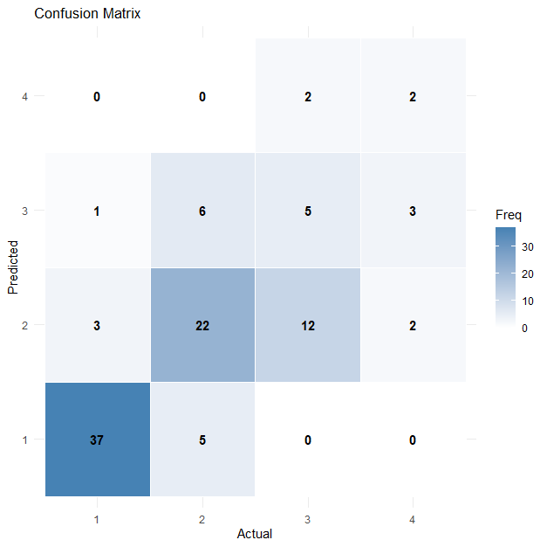
The model accuracy = 0.66 or 66%

We consider this to be a good fit. We conclude that 66% of the responses was correctly predicted by the model. The data set being small and being collected from a primary source, the fit seems to be good.

- Limitations
The number of data points collected were quite small. Which lead to problems like over- parametrization. Since most of the independent variables were ordinal or nominal in nature, each level of the variables is estimated individually. So, using a model with all the variables was not possible.
As the data was collected among undergraduate and postgraduate students, the belief levels seem to be low. The youth is sceptical about zodiac and horoscopes, with only a few exceptions either due to influence of family or media. Many enjoy casual consumption of content on zodiac astrology but they are not active practitioners of it.
Some factors such as Health and Mental health should have a decent influence on Belief, are negated as the population only comprises students. No one has selected the lowest level of these health factors, hence we can conclude that most student have no health complications and also have a healthy state of mind, hence the effect of these variables have not come into much play, although we see some positive association between them.
Lifestyle, which is an indirect representation of economic status, also does not have a very strong effect here. The lowest level was not selected by many individuals as most seem to have a comfortable and affluent life here at St. Xavier’s college. The variation in Age was not large enough to capture the effect of age on astrological belief.

- Conclusion

We obtain an accuracy of 66% with the final model under consideration, which comprises ten variables with the highest association with the response variable Belief. The analysis was based on data collected from primary sources and was small with only hundred data points, considering that the fit seems apt. With a much larger dataset, varying over various age groups would have led to a greater result. None-the-less, with the result achieved has proved our efforts to be worthwhile.

I would once again thank this college and my supervisor, Dr. Sancharee Basak for her support throughout this endeavour.

